learners’ statement

URL: https://github.com/halo-dev/halo

Proposal: This document is a tutorial for learners who have never developed an open-source project. The first is to let users get a general understanding of this project, which has been roughly described in README.md.

Getting started

git clone https://github.com/halo-dev/halo.git



Import the project using IntelliJ IDEA.

Download link: <https://www.jetbrains.com/idea/>

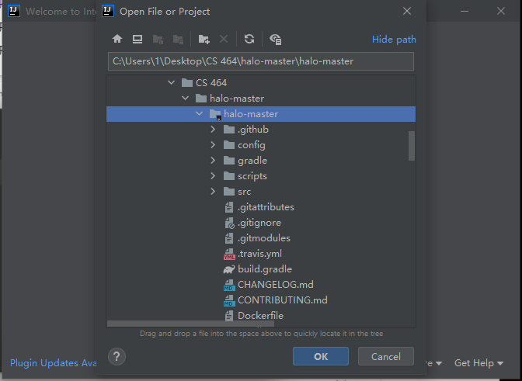

Choose Gradle in Import project from external model, because we can see the build.gradle file in the repo.

Click Use auto-import.

It takes a long time for the first time.

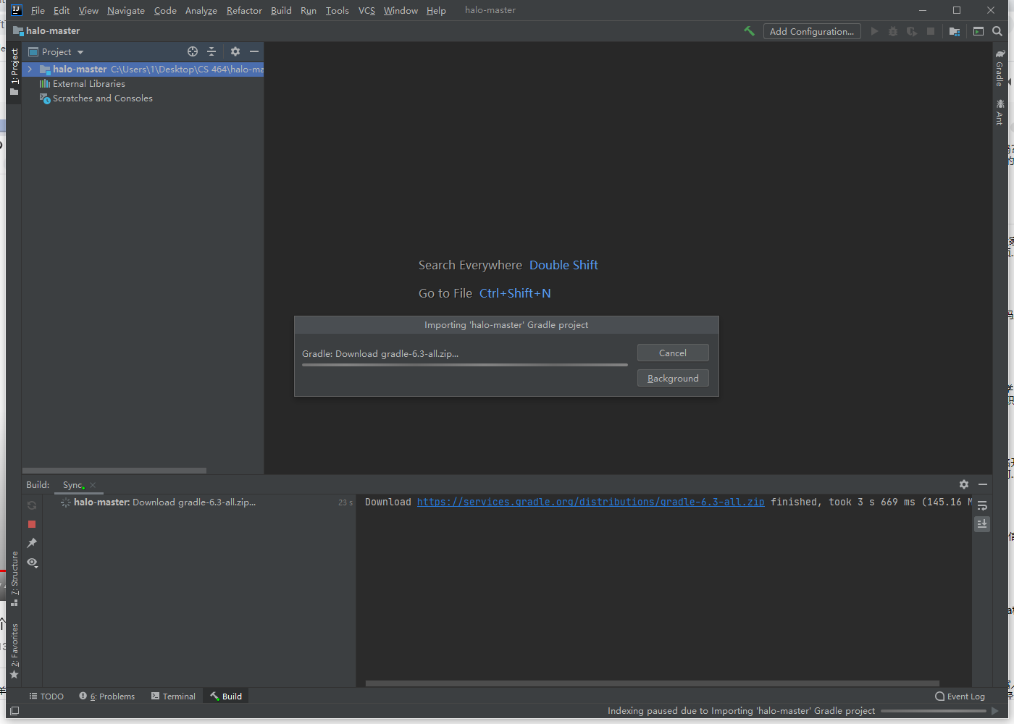

After importing, you can see the required files are displayed on the left.

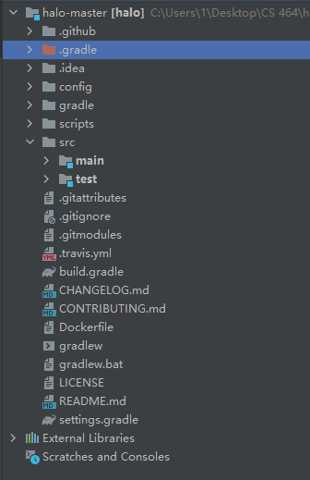

Can be obtained after running:

